**Fractions**

Worksheet – 1

1. Write the fractions for the shaded parts and complete the table.
2. c.

 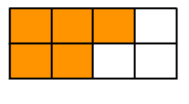

1. d.

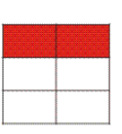 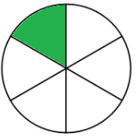

|  |  |  |  |  |
| --- | --- | --- | --- | --- |
| Figure | a. | b. | c. | d. |
| Number of shaded parts (Numerator) |  |  |  |  |
| Number of parts in all (Denominator) |  |  |  |  |
| Fraction of shaded parts |  |  |  |  |

1. Color to show one fourth in red and three fourths in blue.
2. Write two fractions for each as shown.
3. b.

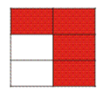 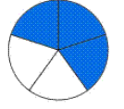

_______ is red. _______ is blue.

_______ is not red. _______ is not blue.

1. Say whether true or false.

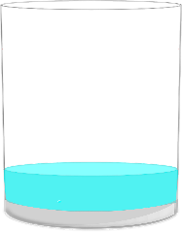 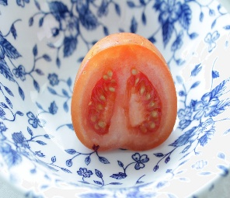 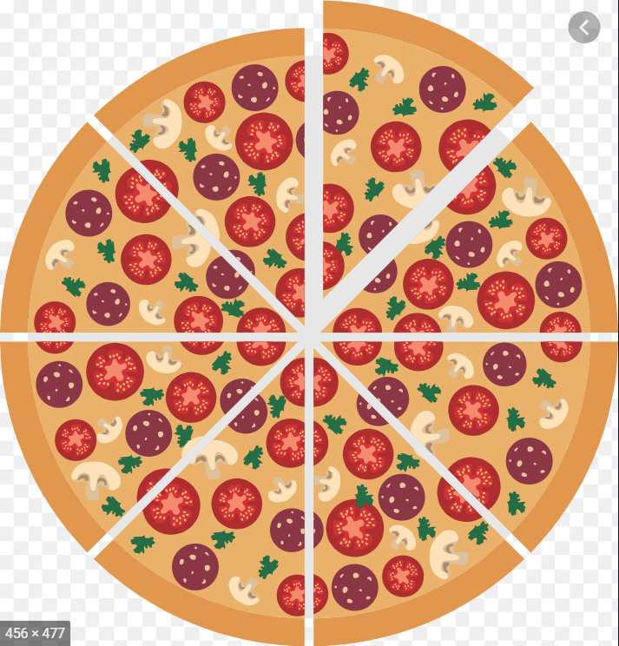

1. $\frac{1}{2}$ the glass has water.
2. $\frac{1}{2}$ the tomato is eaten.
3. 8 people have shared this Pizza.